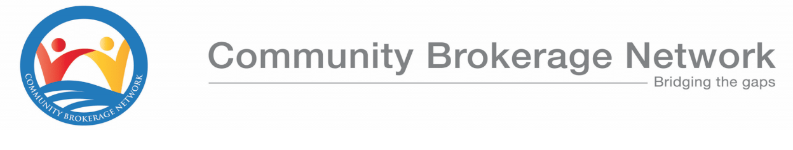

Community Brokerage Award (GL 6804) – Candidate Application Form

Personal Details
Name Click or tap here to enter text.
Address Click or tap here to enter text.
Click or tap here to enter text.
Postcode Click or tap here to enter text.
Date of Birth Click or tap here to enter text.
Phone number Click or tap here to enter text.
Email Address Click or tap here to enter text.
SQA Candidate Number (if applicable) Click or tap here to enter text.
What is the highest level of qualification you have? Choose an item.

Work Details (if applicable)
Employer Click or tap here to enter text.
Job Title Click or tap here to enter text.
Will you be released from work to attend the learning days? Choose an item.

Support Needs
Tell us about any support you think you might need in accessing the course. This will help us to create a support plan for your learning and make sure assessments are accessible.
Click or tap here to enter text.

Tell us about any dietary requirements Click or tap here to enter text.
Do you have IT access to complete online learning and assignments? Choose an item.

Personal Statement
In no more than 500 words, tell us why you are applying for the course, any relevant experience you may have and what you hope to gain from participating.
Click or tap here to enter text.

Paying for the Course
How are you intending to pay for the course? Choose an item.
If your employer is funding the course, please ask your manager to complete the following details
Manager’s name Click or tap here to enter text.
Job Title Click or tap here to enter text.
Phone Number Click or tap here to enter text.
Email Address Click or tap here to enter text.
Organisation’s Address Click or tap here to enter text.

Details for Invoicing Click or tap here to enter text.

Manager’s Signature ________________________________

Declaration

I declare that the information given is correct and any changes to the above details throughout the course will be highlighted to the Community Brokerage Network.
I understand that my details will be held securely by Community Brokerage Network and, if accepted onto the course, will be passed to SQA for certification purposes

Applicant’s Signature _________________________________

Please return your application to jennyreekie@communitybrokeragenetwork.co.uk.

